Lab I - Encryption and Hashing

Timothy Victori

Arizona State University

IFT 202

Gary Grindle

9/29/2024

Screenshot 1 Displaying successfully Generated public and private keys (Part 1)
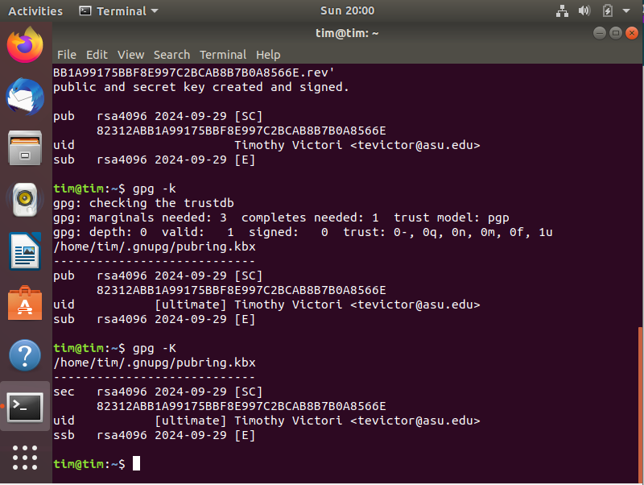
Screenshot 2 showing a successfully decrypted file (Part 2)
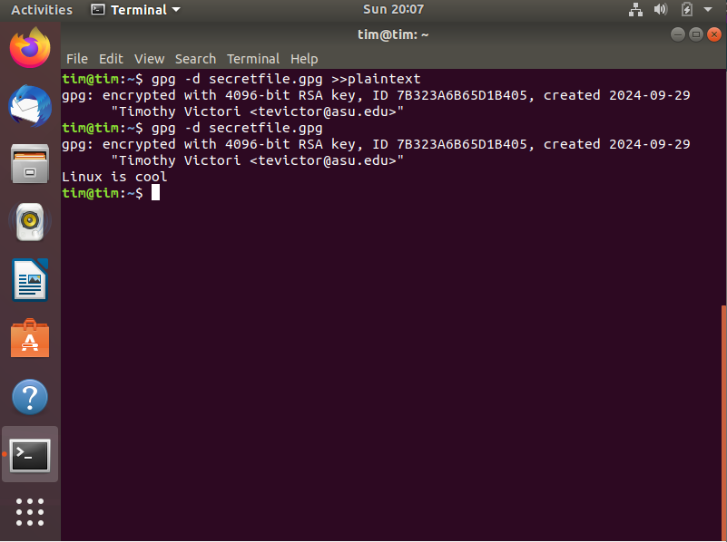
Screenshot 3 showing the public key (Part 3)
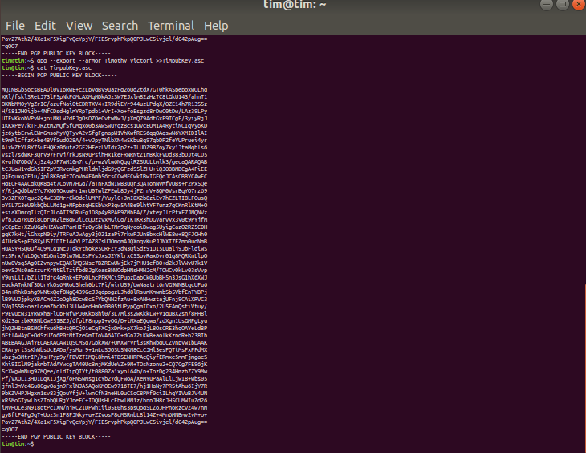
Screenshot 4 showing imported public key on user Alex (Part 4)
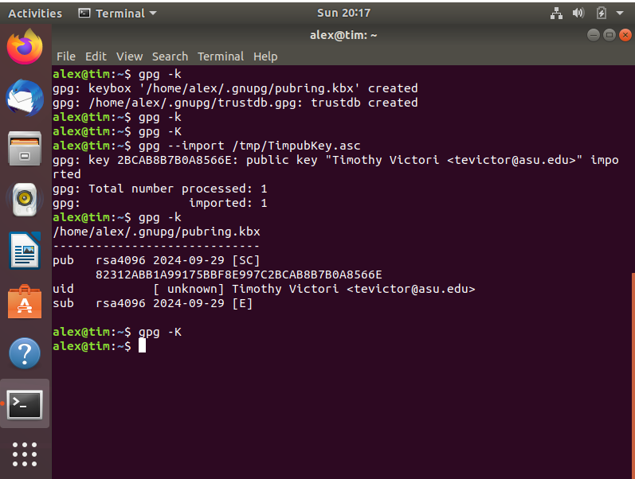
Screenshot 5 showing user Tim decrypting the message sent from user Alex(Part 5)
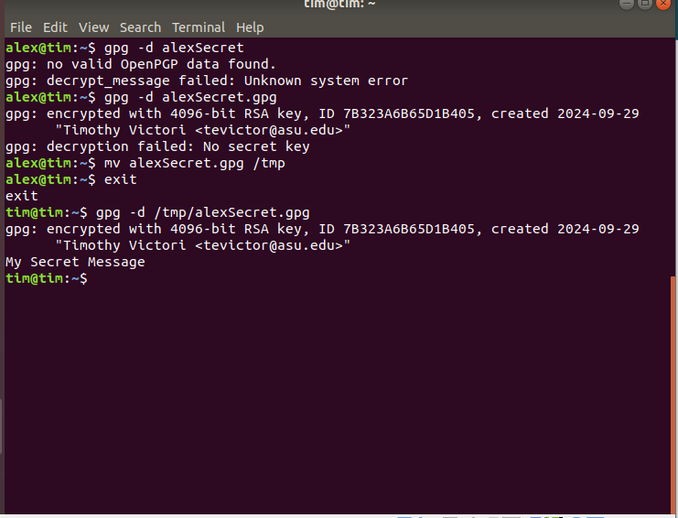
Screenshot 6 showing SHA1 hash(Part 6)
